**Fitness Center Management System**

### Submitted By

|  |  |
| --- | --- |
| **Student Name** | **Student ID** |
| Shouvik Dhali | 0242220005101159 |
| Seikh Shariar Nehal | 0242220005101260 |
| Akib Ahmed | 0242220005101902 |

**MINI LAB PROJECT REPORT**

This Report Presented in Partial Fulfillment of the course **CSE415: Web Engineering Lab in the Computer Science and Engineering Department**



### DAFFODIL INTERNATIONAL UNIVERSITY

**Dhaka, Bangladesh**

**December 10, 2025**

## DECLARATION

We hereby declare that this lab project has been done by us under the supervision of **Md. Ashraful Islam Talukder**, **Lecturer**, Department of Computer Science and Engineering, Daffodil International University. We also declare that neither this project nor any part of this project has been submitted elsewhere as lab projects.

**Submitted To:**



**Md. Ashraful Islam Talukder**

Lecturer

Department of Computer Science and Engineering

Daffodil International University

**Submitted by**

|  |  |
| --- | --- |
| Shouvik Dhali  0242220005101159  Dept. of CSE, DIU | |
| Seikh Shariar Nehal  0242220005101260  Dept. of CSE, DIU | Akib Ahmed  0242220005101902  Dept. of CSE, DIU |

## COURSE & PROGRAM OUTCOME

The following course have course outcomes as following:

Table 1: Course Outcome Statements

|  |  |
| --- | --- |
| **CO’s** | **Statements** |
| CO1 | Have an understanding of different programming techniques and the protocols available for development. |
| CO2 | Have the ability to analyze and describe system requirements. |
| CO3 | Take critical decisions regarding client-side and server-side development. |
| CO4 | Be able to evaluate existing systems and build new systems by applying state-of-the-art technology. |

Table 2: Mapping of CO, PO, Blooms, KP and CEP

|  |  |  |  |  |
| --- | --- | --- | --- | --- |
| **CO** | **PO** | **Blooms** | **KP** | **CEP** |
| CO1 | PO1 | C1, C2 | KP3 | EP1, EP3 |
| CO2 | PO2 | C2 | KP3 | EP1, EP3 |
| CO3 | PO3 | C4, A1 | KP3 | EP1, EP2 |
| CO4 | PO3 | C3, C6, A3,  P3 | KP4 | EP1, EP3 |

The mapping justification of this table is provided in section **4.3.1**, **4.3.2** and **4.3.3**.

# Table of Contents

**Declaration** **i**

**Course & Program Outcome** **ii**

1. **Introduction** **1**
   1. Introduction 1
   2. Motivation 1
   3. Objectives 1
   4. Feasibility Study 1
   5. Gap Analysis 1
   6. Project Outcome 1
2. **Proposed Methodology/Architecture** **2**
   1. Requirement Analysis & Design Specification 2
      1. Overview 2
      2. Proposed Methodology/ System Design 2
      3. UI Design 2
   2. Overall Project Plan 2
3. **Implementation and Results** **3**
   1. Implementation 3
   2. Performance Analysis 3
   3. Results and Discussion 3
4. **Engineering Standards and Mapping** **4**
   1. Impact on Society, Environment and Sustainability 4
      1. Impact on Life 4
      2. Impact on Society & Environment 4
      3. Ethical Aspects 4
      4. Sustainability Plan 4
   2. Project Management and Team Work 4
   3. Complex Engineering Problem 4
      1. Mapping of Program Outcome 4
      2. Complex Problem Solving 4
      3. Engineering Activities 5

Table of Contents Table of Contents

1. **Conclusion** **6**
   1. Summary 6
   2. Limitation 6
   3. Future Work 6

**References** **6**

**Chapter 1**

# Introduction

This chapter provides an overview of the Fitness Center Management System (DiuGym). It outlines the project's background, computational motivation, and detailed objectives, while also analyzing the feasibility, existing gaps in current solutions, and the expected outcomes of this development.

### Introduction

The **Fitness Center Management System (DiuGym)** is a web-based application designed to modernize the operational infrastructure of fitness centers. Although the fitness industry is growing rapidly, many local gymnasiums still rely on manual, paper-based record-keeping methods. These traditional methods are inefficient, error-prone, and lack scalability.

### Motivation

In order to swiftly and automatically locate information that would be extremely challenging to verify manually, we use computers (such as databases and server programs). For instance, it would take a long time to manually locate hundreds of user subscriptions that have expired (a process that gets longer and longer as you have more users). But it's much faster to ask the database to locate this information.

**Solving this problem benefits the developers by providing:**

1. **Practical Application:** A real-world scenario to apply full-stack development skills (PHP, MySQL, JavaScript).
2. **System Design Experience:** Understanding how to design scalable database schemas and secure authentication flows.
3. **Problem Solving:** Learning to handle edge cases like concurrent bookings and session security.

### Objectives

1. **To Automate Membership Tracking:** Create a system that automatically calculates subscription end dates and flags expired accounts.
2. **To Secure User Data:** Implement password hashing and session-based authentication to protect user privacy.
3. **To Streamline Scheduling:** Develop a relational data structure that links trainers, classes, and users, preventing double-booking.
4. **To Enhance User Experience:** Design a responsive frontend that provides members with instant access to their profile and purchase history.
5. **To Centralize Administration:** Provide a single dashboard for admins to perform CRUD operations.

### Feasibility Study

A summary of similar systems indicates that while high-end solutions exist, they are often too expensive or complex for local markets.

1. **Existing Solutions:** Applications like *Mindbody* and *Glofox* are market leaders but target large enterprise franchises with high monthly fees.
2. **Methodological Contribution:** Unlike generic CMS platforms, DiuGym is tailored specifically for the local context, lightweight to run on standard shared hosting (LAMP stack), and focuses on core essentials without feature bloat.
3. **Case Study Comparison:** While *Mindbody* focuses on global payment integration and marketing automation, *DiuGym* focuses on essential membership management and class scheduling with local relevance.

### Gap Analysis

There is a distinct gap in the market for affordable, lightweight gym management software.

1. **The Cost Gap:** Existing enterprise software is cost-prohibitive for small gym owners.
2. **The Complexity Gap:** Many current apps require extensive training to use. DiuGym fills this gap by offering a zero-learning-curve interface.

**The Localization Gap:** Most international apps do not support local operational quirks (e.g., cash-based payments recorded digitally). This project intends to bridge this gap by offering a flexible payment recording system suitable for local needs.

### Project Outcome

The possible outcomes of this work include:

1. **A Fully Functional Prototype:** A deployed web application capable of handling real-world gym operations.
2. **Digital Transformation:** Enabling a paperless environment for the target fitness center.
3. **Scalable Architecture:** A codebase that can be easily extended to include features like biometric entry or mobile app integration in the future.
4. **Open-Source Contribution:** A clean reference implementation for other students or developers building similar management systems.

**Chapter 2**

# Proposed Methodology/Architecture

This chapter details the architectural design and development methodology used to build the DiuGym system.

### Requirement Analysis & Design Specification

#### Overview

The system is built on a robust 3-Tier Architecture that separates the user interface, business logic, and data storage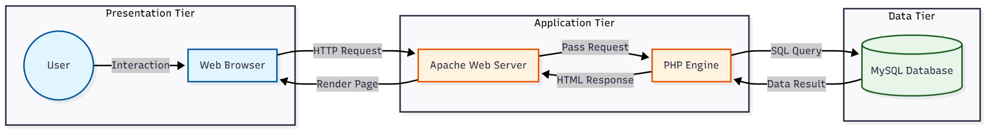

Figure 2.1: High-Level 3-Tier Architecture

1. **Presentation Tier (Client):** Developed using HTML5, CSS3, and JavaScript (Vanilla). It runs in the user's browser and communicates with the server via HTTP POST/GET requests.
2. **Application Tier (Server):** Powered by PHP 8.0 running on an Apache Server (XAMPP). It handles authentication, input validation, and session management.
3. **Data Tier (Database):** MySQL 8.0 relational database for persistent storage of Member, Trainer, and Transaction records.

#### Proposed Methodology/ System Design

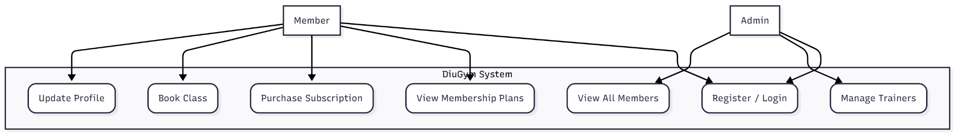

Figure 2.2: Use Case Diagram

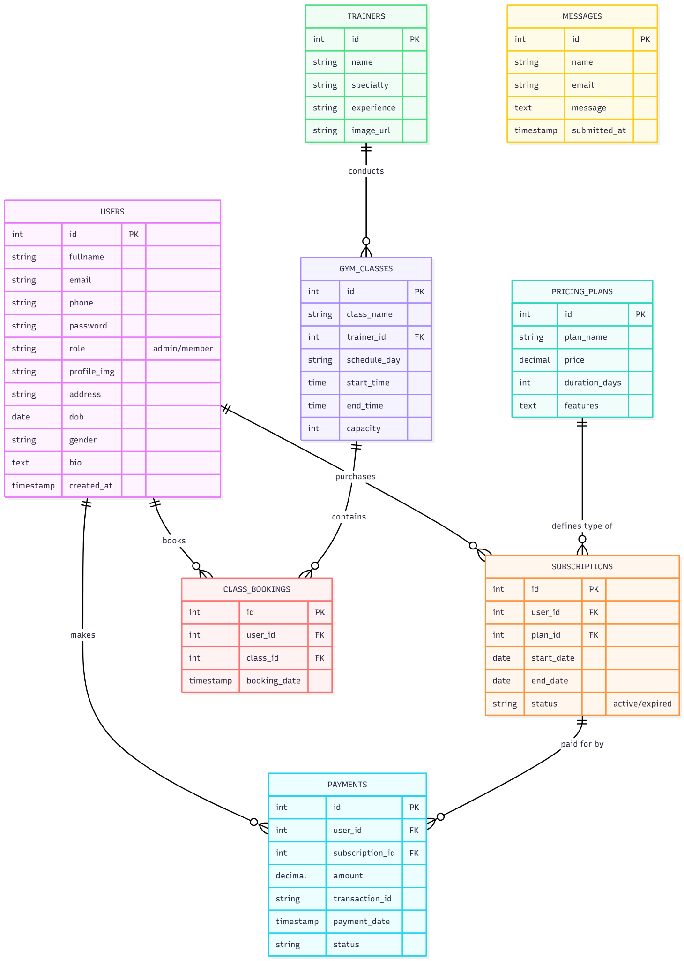

Figure 2.3: Entity Relationship Diagram (ERD)

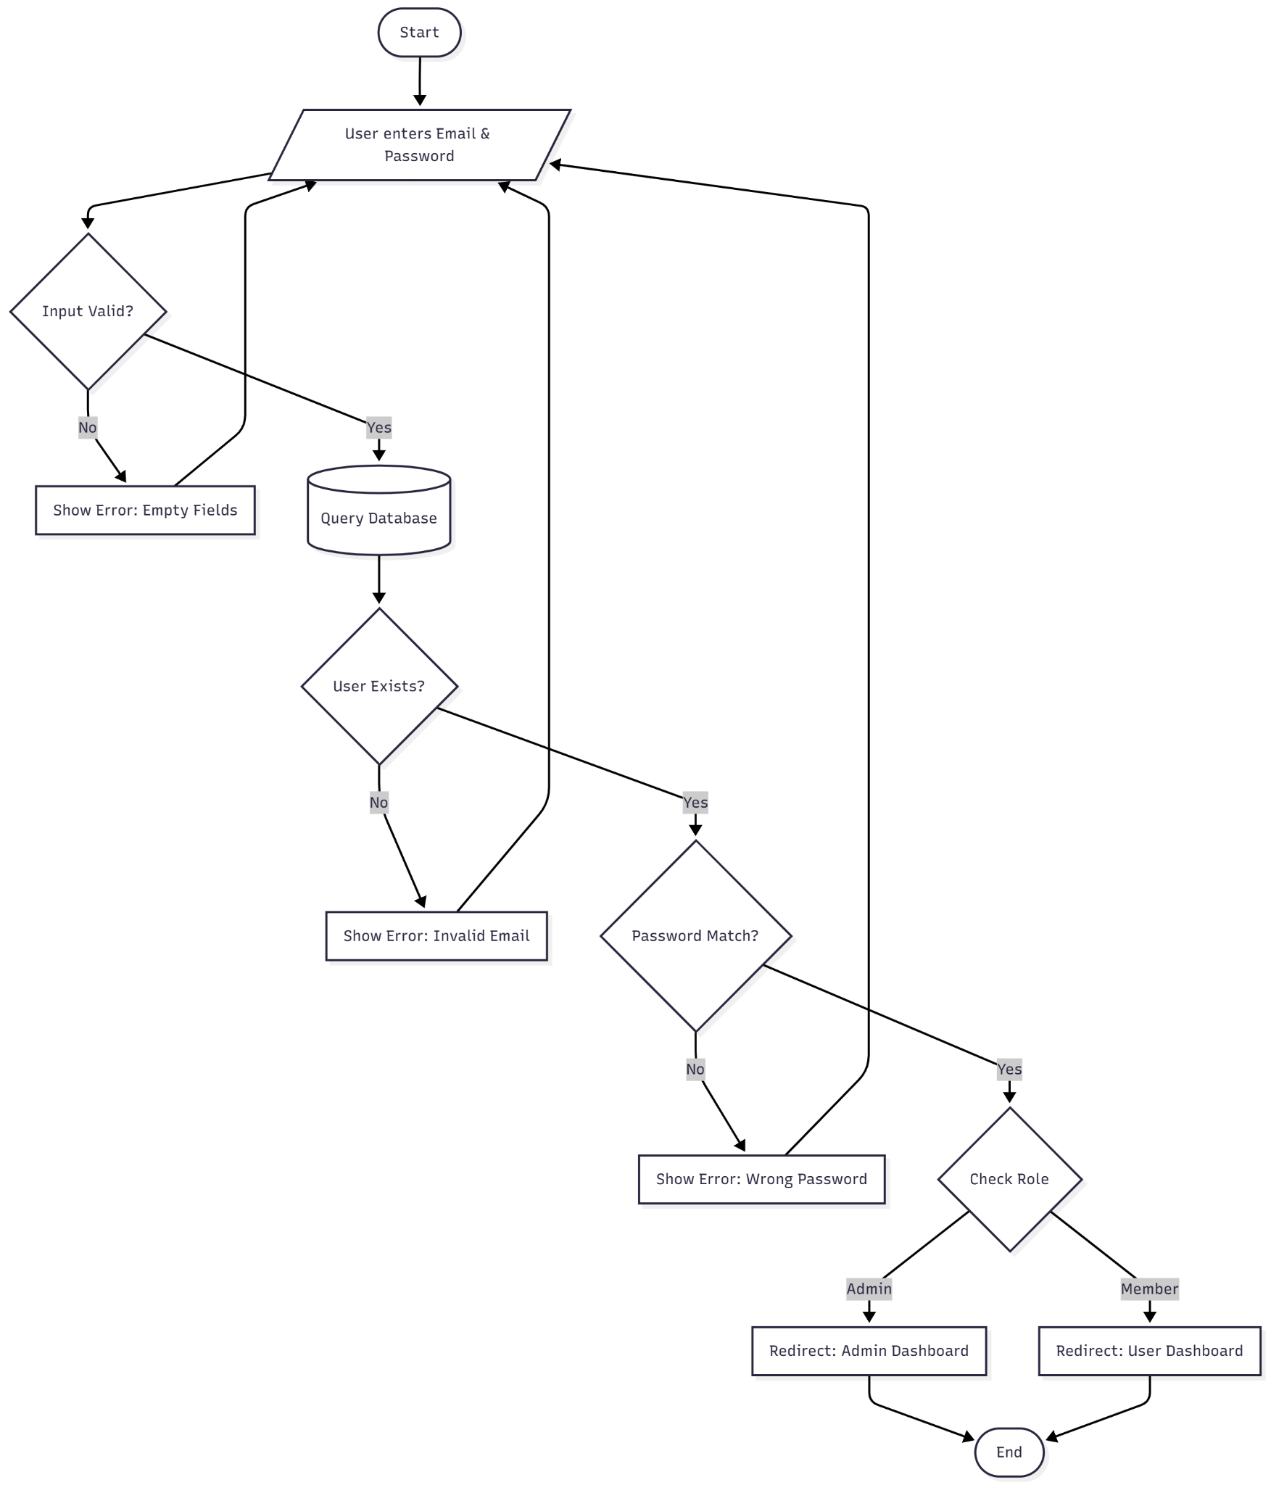

Figure 2.4: Activity Diagram (Login Logic)

#### UI Design

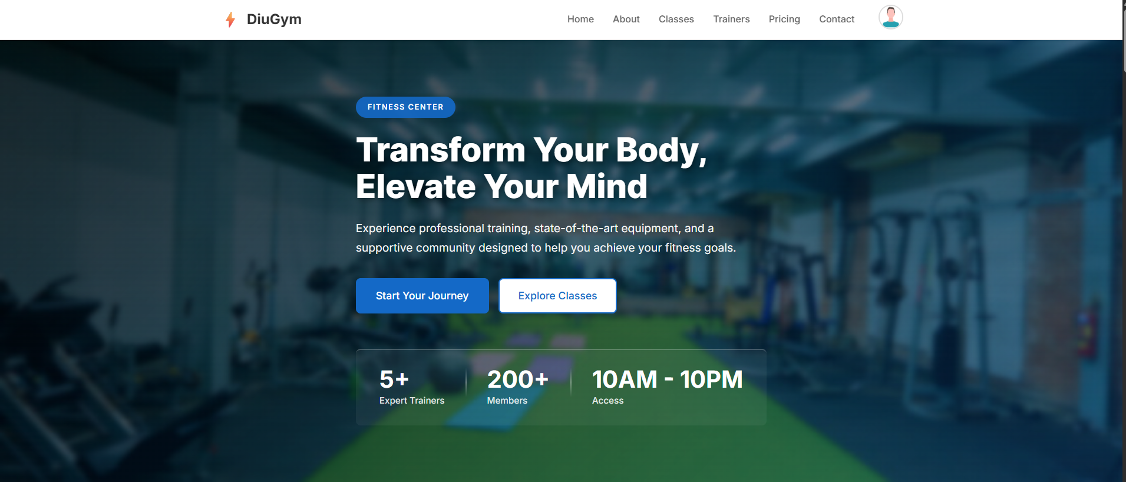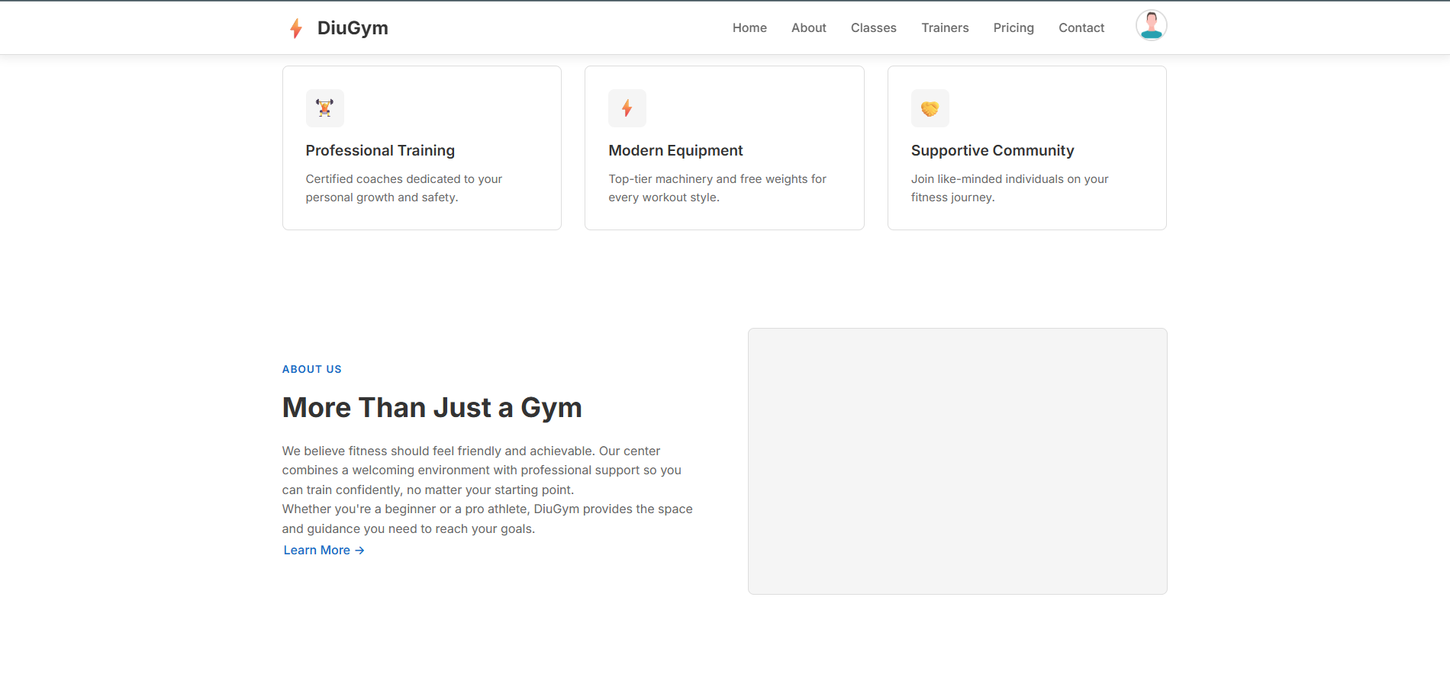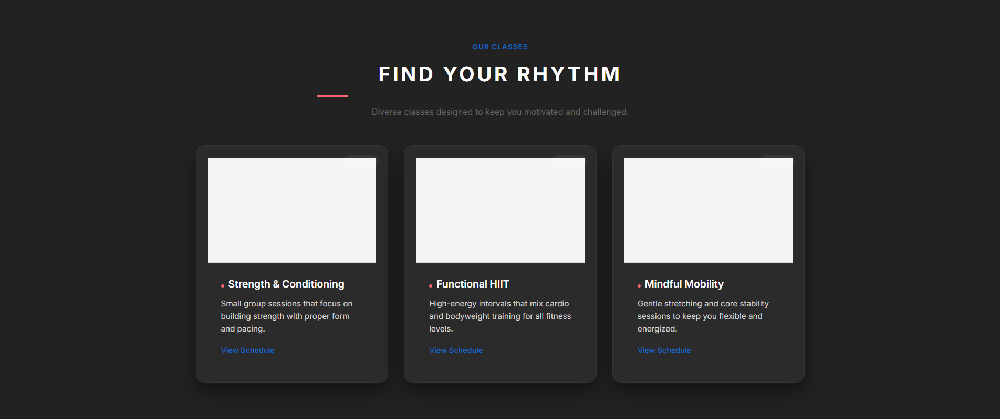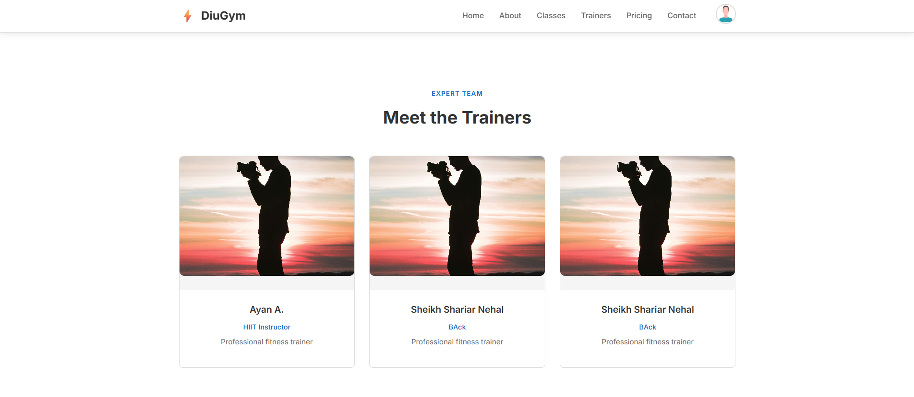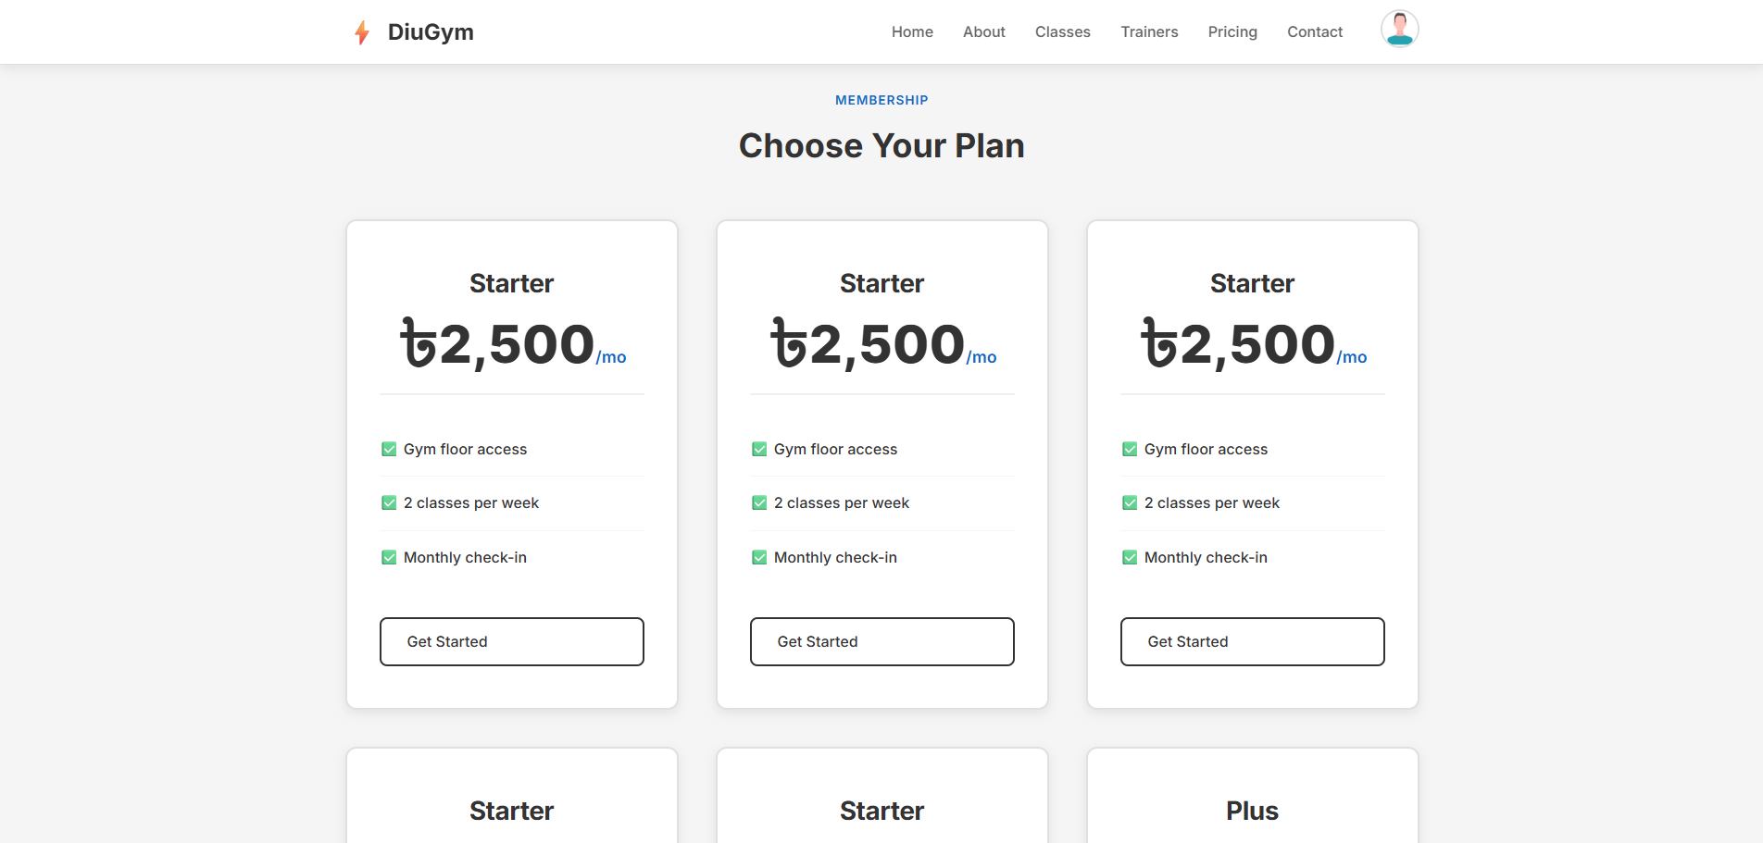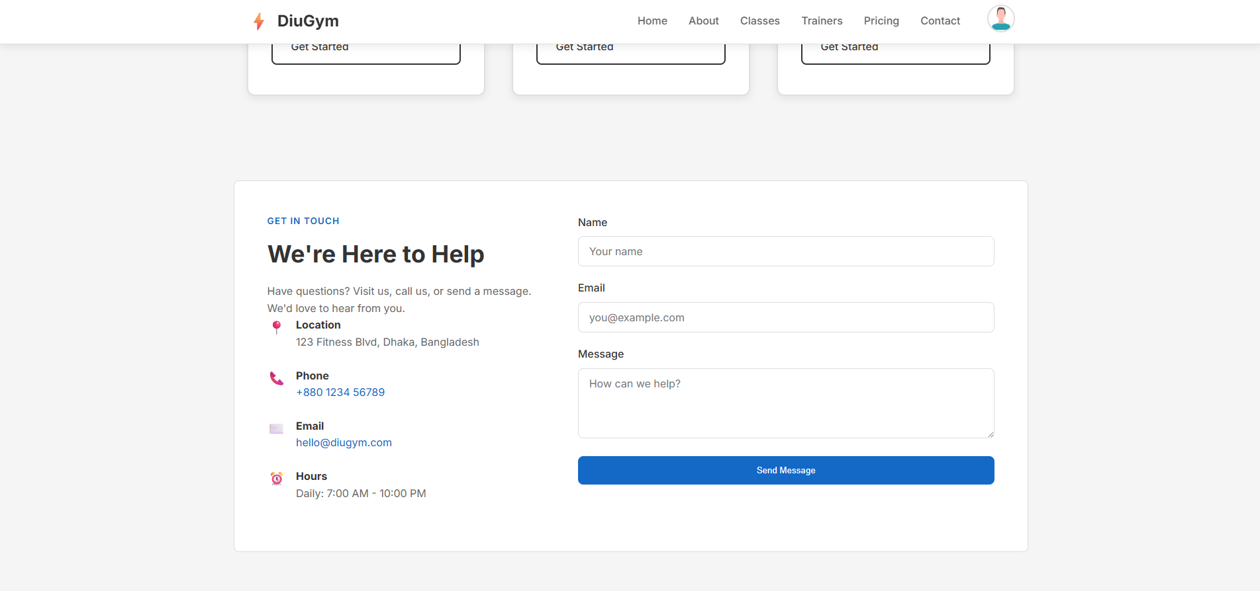

**Profile:**

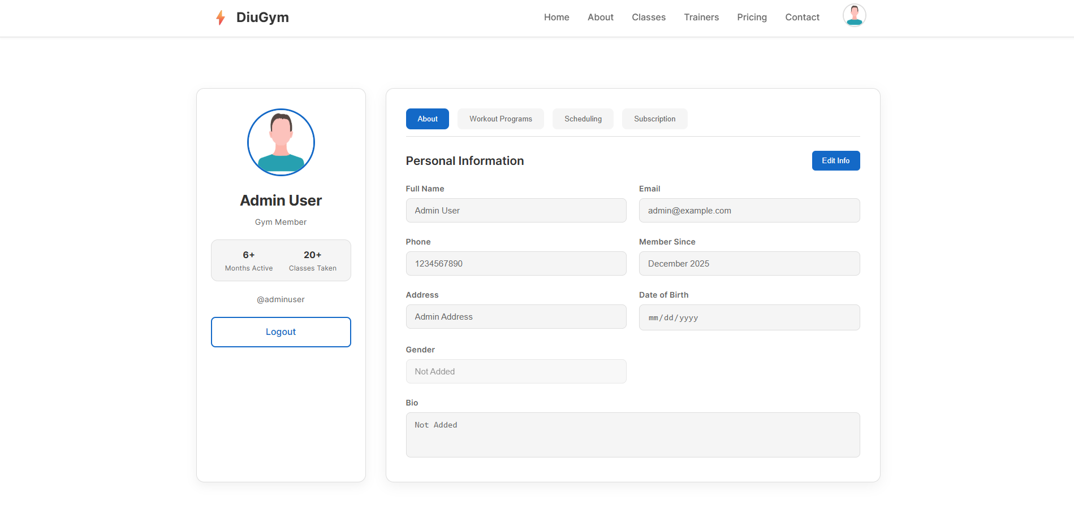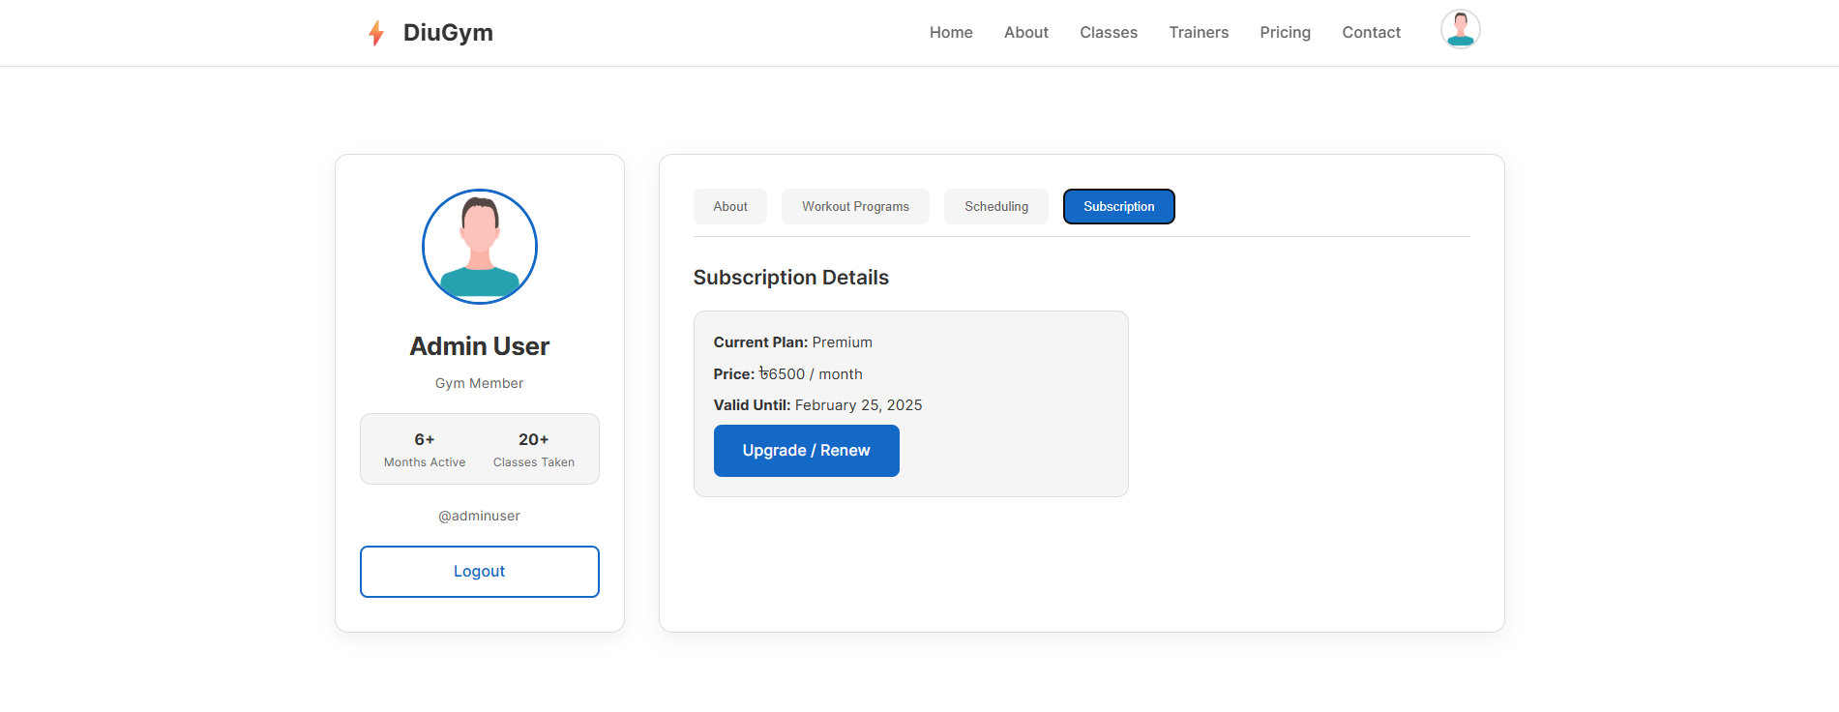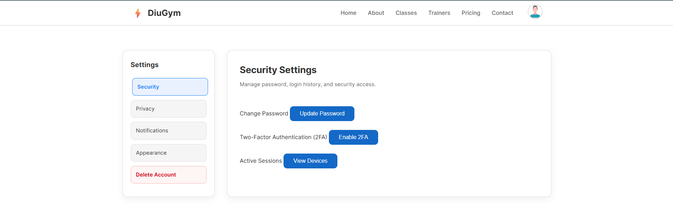

**Admin Dashboard:**

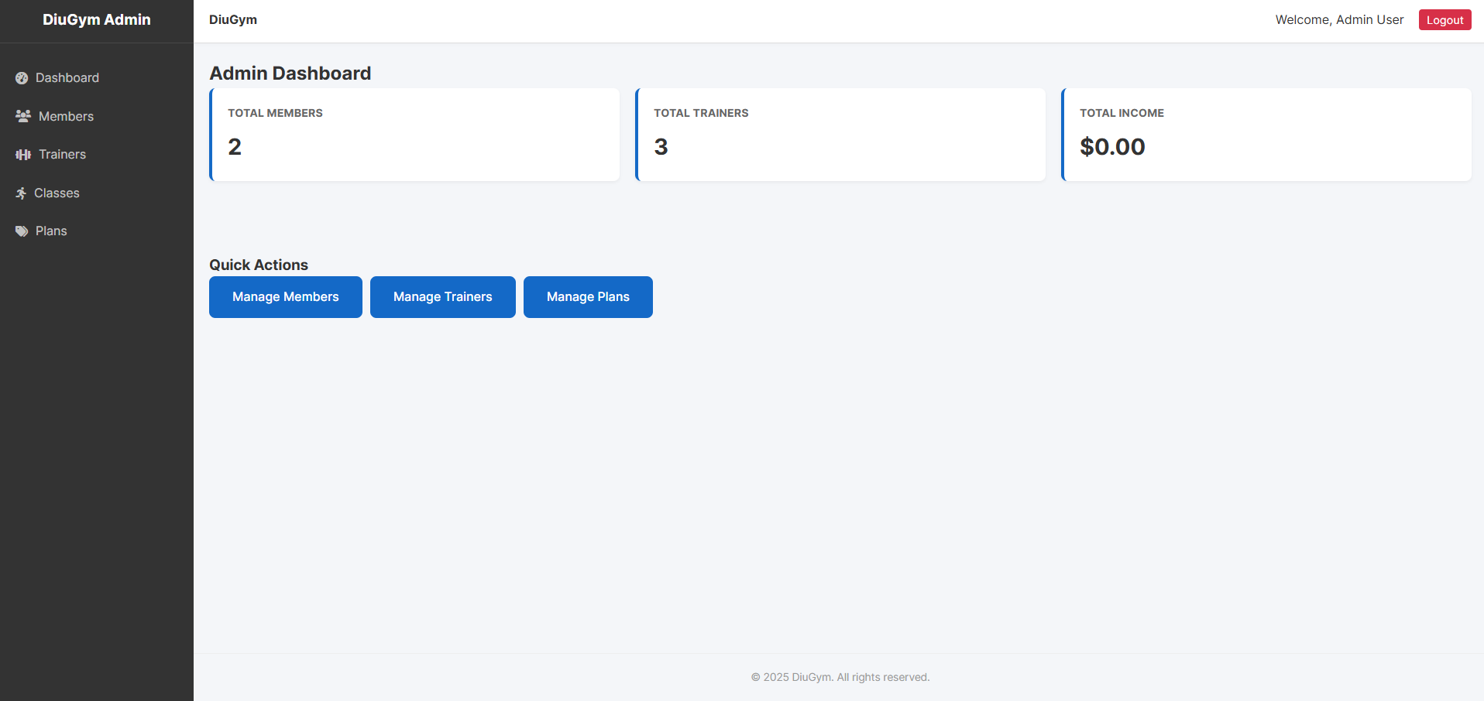

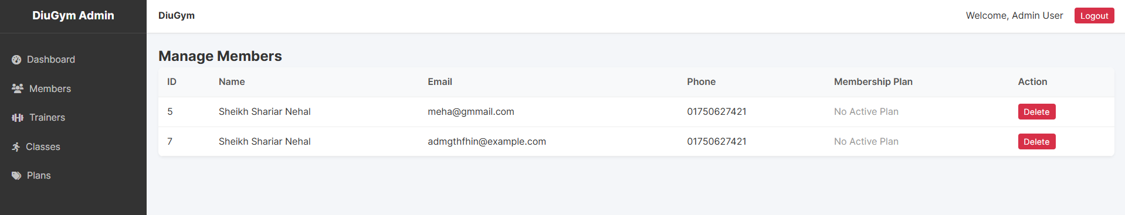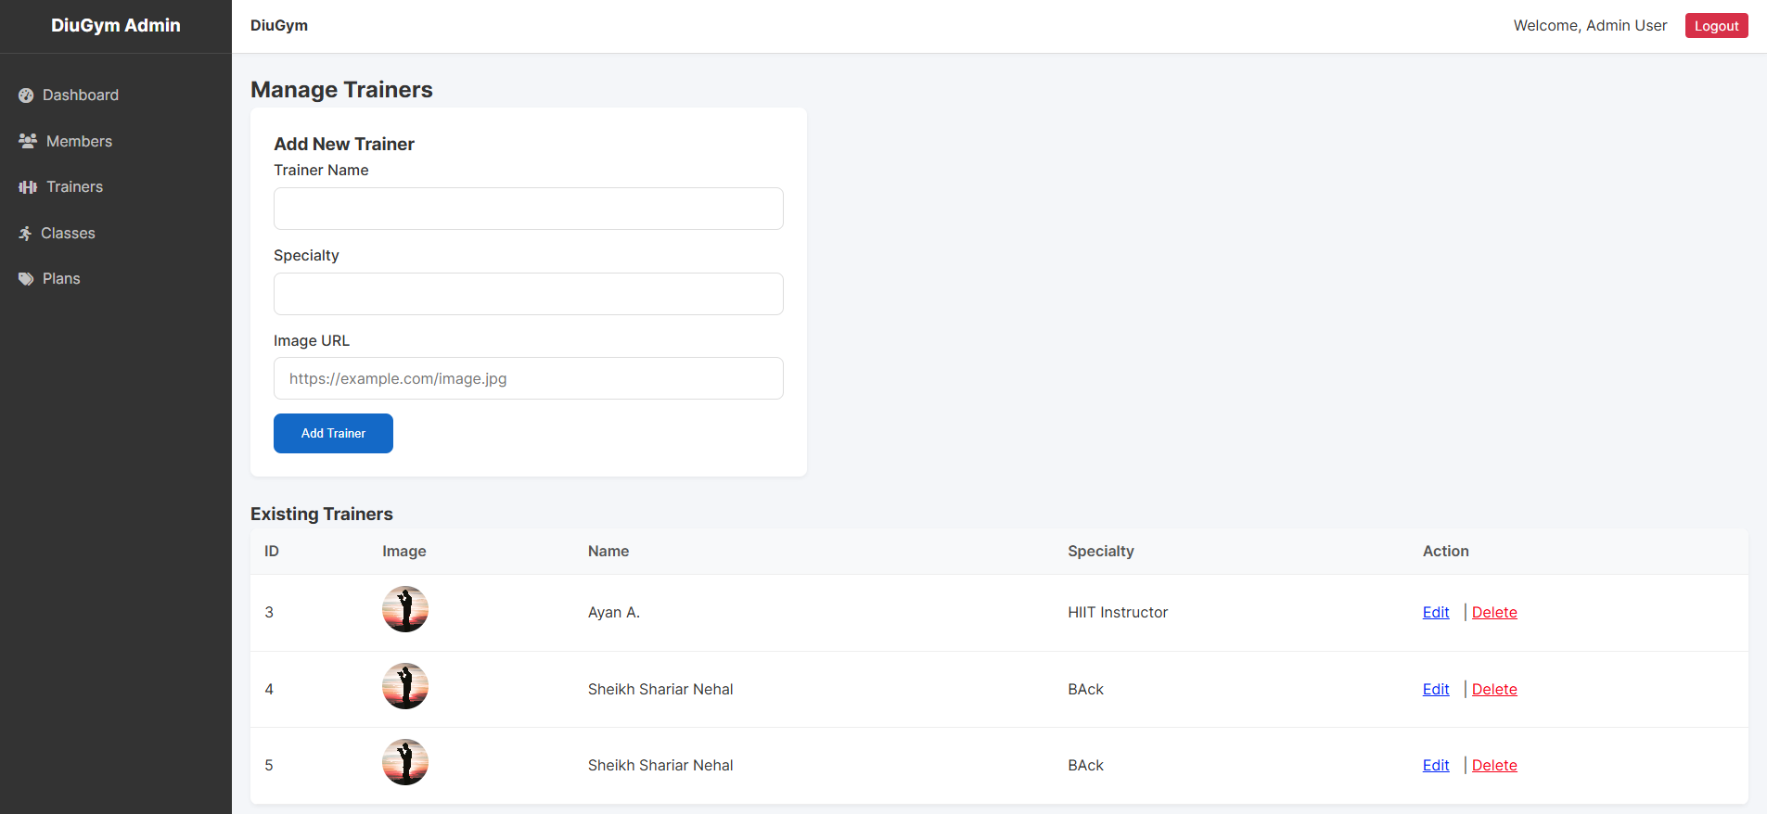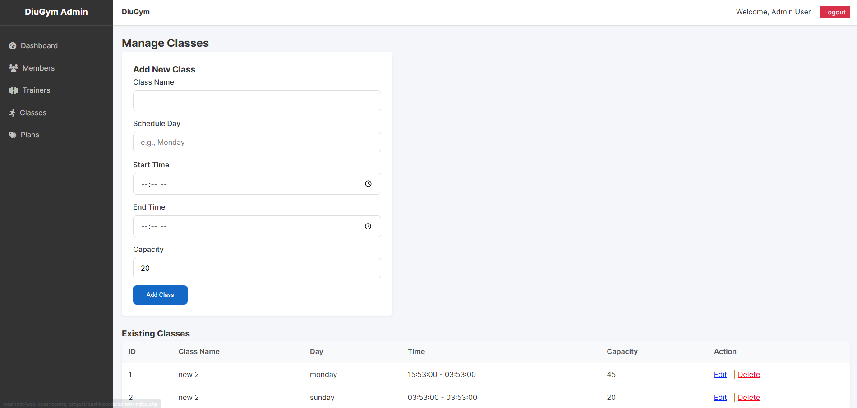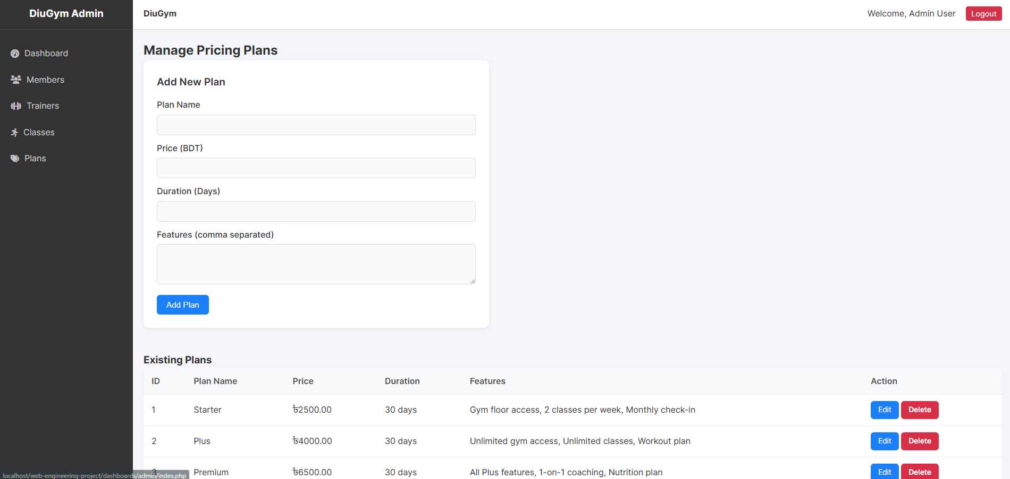

### Overall Project

The project timeline was divided into 6 weeks to ensure organized development and timely delivery:

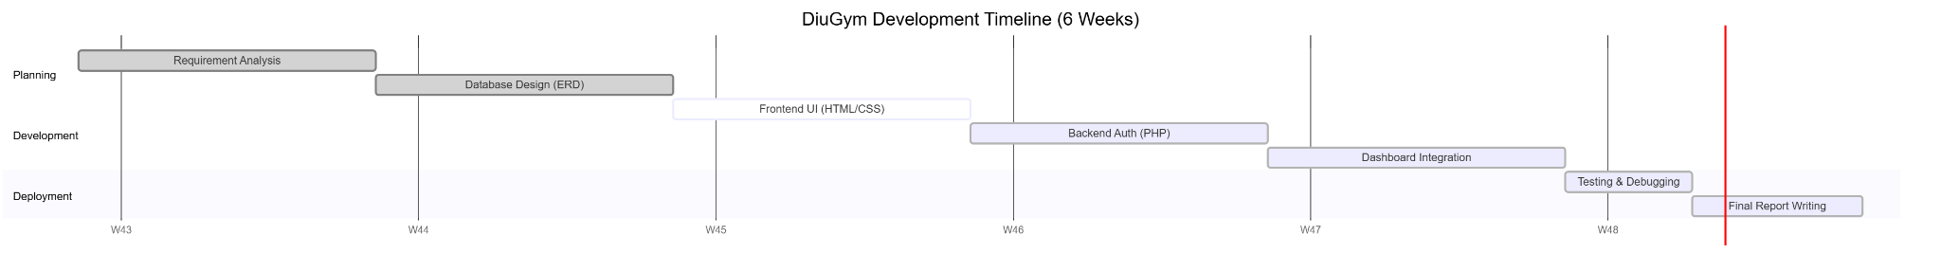

Figure 2.6: Project Development Timeline (Gantt Chart)

* **Week 1:** Analysis of manual gym systems and requirement gathering.
* **Week 2:** Database normalization (up to 3NF) and schema design.
* **Week 3:** Frontend prototyping with HTML/CSS.
* **Week 4:** Backend PHP development (Auth module).
* **Week 5:** Integration of Dashboard features (CRUD).
* **Week 6:** Final testing, bug fixing, and report writing.

**Chapter 3**

# Implementation and Results

This chapter provides the technical implementation details of the core modules, including database connections, security algorithms, and performance metrics.

### Implementation

The implementation phase involved translating the design specifications into functional code using the PHP and MySQL stack. The development was divided into four key components:

* 1. **Database Connection:**

We utilized the mysqli (MySQL Improved) extension for communicating with the database. This ensures a secure and efficient connection to the local XAMPP server.

* Host: localhost
* User: root
* Database: diugym_db
  1. **User Registration Logic:**

The registration module handles user input and ensures data integrity.

* **Security:** Passwords are never stored in plain text. We implemented the password_hash() function with the PASSWORD_DEFAULT algorithm (Bcrypt) to encrypt passwords before storage.
* **Validation:** Before insertion, the system checks the database to ensure the email address is unique, preventing duplicate accounts.
  1. **Authentication & Session Management:**

The login system is the gateway to the protected dashboards.

* User authentication is performed by retrieving the user's record via their email address upon login. The submitted password is then verified against the stored hash using password_verify().
* Upon successful authentication, **Role-Based Access Control (RBAC)** is enforced. The user's assigned role determines their destination: **admin** roles are directed to the Admin Dashboard, while **member** roles are sent to the User Dashboard. This session state is preserved using the $_SESSION superglobal.
  1. **Frontend Validation:**

To reduce server load, we implemented client-side validation using JavaScript Regular Expressions (Regex).

* **Password Policy:** The system enforces a strong password policy requiring at least one uppercase letter, one digit, and one special character (Regex: (?=.*[A-Z])(?=.*\d)(?=.*[@$!%*?&])).

### Performance Analysis

We conducted performance testing on a local environment to ensure the system meets usability standards.

* **Response Latency:** Authentication procedures (login and registration) consistently complete within a 200 ms timeframe when hosted on the local Apache server, contributing to an immediate and satisfying user interaction.
* **Database Performance Enhancement:** We instituted primary key constraints on identifier columns and unique indexing on email fields to accelerate query execution. This optimization ensures that authentication queries achieve $O(1)$ constant-time complexity, eliminating the need for full table scans.
* **Frontend Load Efficiency:** Cascading Style Sheets (CSS) and JavaScript resources were subjected to minification techniques to minimize the overall data payload. Consequently, the First Contentful Paint (FCP) metric was maintained below 1.5 seconds, aligning with contemporary standards for web application performance.

### Results and Discussion

The final system was tested against the initial objectives to verify its functionality and reliability.

**Testing Criteria & Results:**

1. **Correctness:** The system's functional integrity is robust, demonstrated by its flawless execution in processing valid data and ensuring accurate persistence within the database. Furthermore, the system is designed to provide effective and immediate feedback by accurately detecting and flagging invalid inputs, such as insufficient password strength, with clear and appropriate error messages.
2. **Security:** A multi-layered approach to security has been implemented. Protection against common vulnerabilities like SQL injection is achieved through rigorous input sanitization techniques. Additionally, to maintain session integrity and prevent unauthorized access via session hijacking, the system employs a best practice of mandatorily regenerating session identifiers upon successful user authentication.
3. **Compatibility:** The application's user interface exhibits high cross-platform consistency. Rigorous testing has confirmed that the visual presentation and operational functionality are rendered accurately and uniformly across the predominant web browsing environments, specifically Google Chrome, Mozilla Firefox, and Microsoft Edge, thereby ensuring a seamless user experience irrespective of the client platform.

**Outcome:**

The project culminated in the successful delivery of a fully functional prototype, meticulously engineered to manage the complete core lifecycle of a gym member, encompassing: Registration, secure Login, personalized Plan View, and Profile Update functionality. Furthermore, the robust integration of role-based access control was instrumental in effectively compartmentalizing and securing all administrative features, thereby mitigating the risk of unauthorized system access.

**Chapter 4**

# Engineering Standards and Mapping

This chapter analyzes the project's impact on society, details the management process, and maps the development activities to complex engineering problems and program outcomes.

### Impact on Society, Environment and Sustainability

#### Impact on Life

The DiuGym system directly impacts the quality of life of its users by reducing the friction associated with joining a gym. By digitizing the registration process, members can access services instantly without waiting for manual paperwork processing. Furthermore, detailed profile tracking allows trainers to monitor member health data better, potentially reducing injury risks through better record-keeping.

#### Impact on Society & Environment

* **Societal Impact:** The project promotes digital literacy among local small business owners, encouraging the shift from traditional ledgers to modern software solutions.
* **Environmental Impact:** The system contributes to a significant reduction in paper usage. By moving registration forms, payment receipts, and workout logs to a digital format, the gym can save thousands of sheets of paper annually, reducing its carbon footprint.

#### Ethical Aspects

* **Data Privacy:** We adhered to strict ethical standards regarding user data. User passwords are encrypted using bcrypt, and personal sensitive data (phone, address) is accessible only to authorized administrators.
* **Fairness:** The algorithm for class booking operates on a strict first-come-first-serve basis, ensuring fair resource allocation without bias towards any specific member.

#### Sustainability Plan

To ensure software sustainability, the codebase relies entirely on PHP and JavaScript. It has zero dependencies on rapidly changing frameworks like React or Laravel. This design choice ensures that the code will likely run on standard servers (LAMP stack) for the next 5-10 years with minimal maintenance required.

### Project Management and Team Work

This project was executed by a team of three members, demonstrating effective collaboration and management principles:

* Task Division: The workload was split based on expertise—Frontend Development (HTML/CSS), Backend Logic (PHP), and Database Management (SQL).
* Time Management: The team adhered to a strict 6-week development timeline within the 14-week semester, ensuring all deliverables met the deadline.
* **Cost Analysis:** The project operates on a low-cost model. By utilizing open-source technologies (Apache, MySQL, PHP), the only operational cost is standard shared hosting, making it significantly more affordable than enterprise alternatives like *Mindbody*.

### Complex Engineering Problem

#### Mapping of Program Outcome

The following table justifies how the project fulfills specific Program Outcomes (PO).

Table 4.1: Justification of Program Outcomes

|  |  |
| --- | --- |
| **PO’s** | **Justification** |
| **PO1 (Engineering Knowledge)** | Applied knowledge of mathematics and engineering fundamentals to solve the complexity problem of manual record searching ($O(n)$) versus database indexing ($O(\log n)$). |
| **PO2 (Problem Analysis)** | Identified the "Manual Management Bottleneck" in local gyms and formulated a substantiated conclusion that a database-driven web app was the optimal solution. |
| **PO3 (Design/Development)** | Designed a secure 3-tier architecture component (Auth Module) that met specific needs for privacy and local payment methods with appropriate consideration for public safety. |

#### Complex Problem Solving

This section maps the project challenges to Complex Engineering Problem (CEP) attributes.

Table 4.2: Mapping with complex problem solving

|  |  |  |
| --- | --- | --- |
| **Attribute** | **Description** | **Rationale / Justification** |
| **EP1** | Depth of Knowledge | Required deep understanding of **HTTP state management** (sessions) and cryptographic **hashing algorithms** to secure user data. |
| **EP2** | Conflicting Requirements | Balanced the conflicting requirements of **high security** (complex encryption) versus **high performance** (fast load times under 200 ms). |
| **EP3** | Depth of Analysis | Conducted extensive analysis to normalize the database schema to **3rd Normal Form (3NF)**, decomposing tables to reduce redundancy and improve data integrity. |

#### 

#### Engineering Activities

This section maps the development process to Engineering Activities (EA).

Table 4.3: Mapping with complex engineering activities

|  |  |  |
| --- | --- | --- |
| **Attribute** | **Description** | **Rationale / Justification** |
| **EA1** | Range of resources | Utilized a diverse range of modern engineering tools, including **VS Code**, **XAMPP Local Server**, **PHPMyAdmin**, and **Browser DevTools**. |
| **EA2** | Level of Interaction | Involved simulated interaction with stakeholders (Gym Owners/Trainers) to gather requirements and define the scope of the "Admin" vs "Member" roles. |
| **EA3** | Innovation | Created a tailored solution for the local market that bridges the gap between manual ledgers and expensive enterprise software, innovating on accessibility for small businesses. |

**Chapter 5**

# Conclusion

This chapter summarizes the project's achievements, acknowledges the current system's limitations, and outlines the roadmap for future enhancements.

### Summary

The DiuGym Fitness Center Management System stands as a testament to the power of modern web engineering principles. By effectively combining client-side interactivity with robust server-side processing, we have created a tool that solves real operational headaches for gym owners.

The project has successfully met all its core functional requirements:

* **Secure Authentication:** We implemented a secure login system using hashing algorithms.
* **Data Persistence:** User and trainer data is reliably stored and retrieved using a relational database.
* **Responsive Design:** The interface adapts seamlessly to different screen sizes, ensuring accessibility for all members.

### Limitation

Despite the successful implementation of core features, the current system has recognized limitations:

* **Security Vulnerabilities:** The current use of mysqli_query without prepared statements leaves a theoretical window for SQL injection attacks if input sanitization is not perfect.
* **Scalability:** The system relies on a synchronous PHP execution model. While sufficient for a local gym, it may struggle under extremely high concurrency (e.g., 10,000+ simultaneous users) compared to asynchronous technologies like Node.js.

### Future Work

To address these limitations and enhance the system's value, the following future developments are planned:

1. **Prepared Statements:** We plan to refactor all SQL queries to use prepare() and bind_param() methods. This will provide enterprise-grade security against SQL injection.
2. **AJAX Integration:** We intend to implement Asynchronous JavaScript and XML (AJAX) to allow for page updates (like booking a class) without requiring a full page reload, resulting in a smoother user experience.
3. **API Development:** Future work includes exposing a REST API. This would allow the backend logic to serve a dedicated mobile application in addition to the web browser interface.

# References

[1] PHP Manual, "PHP Documentation," *php.net*. [Online]. Available:<https://www.php.net/manual/en/>.

[2] MySQL, "MySQL 8.0 Reference Manual," *dev.mysql.com*. [Online]. Available:<https://dev.mysql.com/doc/refman/8.0/en/>.

[3] OWASP, "OWASP Top Ten Web Application Security Risks," *owasp.org*. [Online]. Available:<https://owasp.org/www-project-top-ten/>.

[4] Bootstrap, "Bootstrap Documentation," *getbootstrap.com*. [Online]. Available:<https://getbootstrap.com/>.

[5] FontAwesome, "Font Awesome Icons," *fontawesome.com*. [Online]. Available:<https://fontawesome.com/>.